Snakes, Dragons, and Other Scaly Creatures
Saturday, March 5, 2016
The C. G. Jung Center of New York
28 East 39th Street, New York, NY
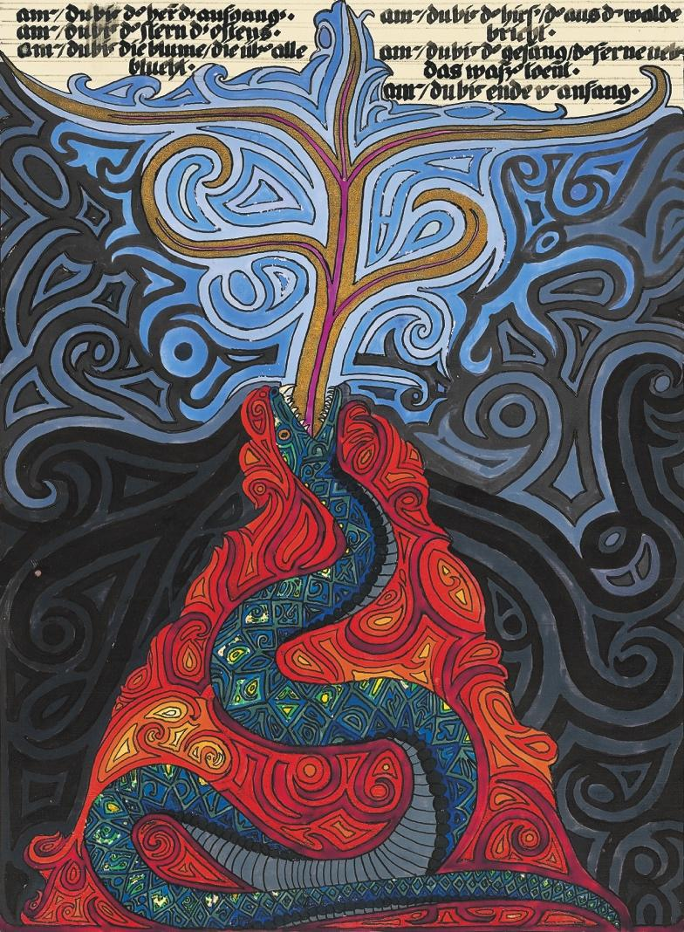
This event is co-sponsored by the C. G. Jung Institute of New York (http://www.junginstitute.org), the New York Association for Analytical Psychology (http://www.nyaap.org), the C. G. Jung Foundation of New York (http://www.cgjungny.org), the Archive for Research in Archetypal Symbolism (http://aras.org), and the Analytical Psychology Club of New York (http://jungclubnyc.org).
From February 29 to April 1, 2016, the Salena Gallery of Long Island University - Brooklyn will host an exhibition of the Digital Fusion prints (theredbookprints.com) from Jung’s Red Book. These magnificent 25x33 inch reproductions of Jung’s paintings made their art world debut at the 55th Annual Venice Biennale in 2013, where the original manuscript of the Red Book was on display. All conference participants are cordially invited to the Opening
Reception on Friday evening, March 4, 6:00-8:00 p.m. at the gallery at One University Place, Brooklyn (www.facebook.com/liubrooklynart).
The Conference will open at 9 a.m. on Saturday, March 5, with a keynote address by Ami Ronnberg, Curator of the Archive for Research in Archetypal Symbolism (ARAS), followed by 30-minute presentations focusing on images of the serpent and its multivalent representations. The presentations will lead us into realms such as psychological theory, mythology, clinical practice, and contemporary culture. The format will be three moderated panels, each featuring three speakers, with time for lively discussion.
CONFERENCE SPEAKERS
- Ami Ronnberg (keynote) National Curator at ARAS – “The Transforming Snake in Jung’s Red Book”
- Fanny Brewster, PhD, MFA Jungian Analyst (NYAAP) – “Wisdom of the Feminine Serpent”
- Michael Conforti, PhD Jungian Analyst (NYAAP) – “When the Gods Grow Weary: Archetypal Transitions of a New Order”
- Sanford Drob, PhD Core Faculty, Fielding Graduate University – “Black Snake/White Snake: Snakes and Serpents and the Reconciliation of the Opposites in Jung’s Red Book”
- Sarah Jackson, MFA, MA Jungian Analyst (NYAAP) – “Situating Jung’s Scaly Creatures in an Art Historical Context”
- Ann Chia-Yi Li, MA Jungian Analyst (AGAP) – “The Golden Flower that Blooms in The Red Book, a Daoist Alchemical Interpretation of the Dragon Images”
- Ilona Melker, LCSW Jungian Analyst (NYAAP) – “Snakes in the Visions of Christiana Morgan, the Veiled Woman in Jung’s Visions Seminars”
- Hallfridur Ragnheidardottir, MA in Icelandic Literature – “The Snake, the Dragon, and the Menstruating Womb”
- Evans Lansing Smith, PhD Chair/faculty of Mythological Studies Program, Pacifica Graduate Institute – “A Modernist Nekyia: Jung’s Myth of Analysis and Transformation”
- David Solem, MSW, MA Jungian Analyst (NMSJA, IRSJA) – “Befriending, not Becoming, the Dragon”
Registration and payment via Eventbrite: www.snakesanddragonsnyc.eventbrite.com

Fee for the conference is $100. $150 after January 15.
Early registration is recommended, as space is limited.
For questions, please email snakesanddragonsnyc@gmail.com

DIRECTIONS TO PURCHASE TICKETS

FOR SNAKES, DRAGONS AND OTHER SCALY CREATURES EVENT MARCH 5TH 2016

- GO TO EVENTBRITE.COM
- TYPE IN YOUR E MAIL ADDRESS
- CREATE A PASSWORD ( IF YOU ALREADY HAVE AN ACCOUNT WITH ANOTHER SITE LIKE PAYPAL, IT WILL TELL YOU TO LOG IN)
- SEARCH FOR THE EVENT SNAKES, DRAGONS AND OHER SCALY CREATURES EVENT
- THE SITE WILL ASK FOR A PAYMENT FOR $100 FOR THE TICKET PLUS $6. 40 FOR PROCESSING FEE. YOU CAN THEN PAY BY ANY OF THE CREDIT CARDS.

