The New Directions Committee of APC Presents

Native American Spirituality, Shamanism and Healing in the U.S.

James J. Wisecup: DMIN.

At the C.G. Jung Center, 28 East 39th St, NYC
April 30th, 2016: 10 AM to 3 PM

contact@jungclubnyc.org/212 557-1502

Members and Seniors: $35; Non-Members: $45; Students with IDs: $15

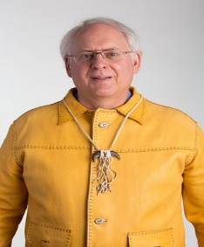 This presentation will include Native American activities for starting and conducting rituals: i.e. “Greeting the Sun and the Day;” “Laying the Alter and Smudging the Alter and Sacred Objects and Smudging Each Person;” Calling in the Spirits;” and “Drumming.” These activities build up the Spirit energy.

The workshop will present the Native American view of cosmology and their idea of being in relationship with all beings. The Sacredness of all creation is an important reality that is lived on a daily basis.

Shamanism and spiritual; and healing work will be presented in depth. Several journeys with drumming will be conducted. The concepts of Core Shamanism as taught by The Foundation for Shamanic Studies will be explained at length and experienced by taking journeys to the Lower World, the Upper World and the Middle World. Participants will also experience Soul Retrieval if time permits. Partakers will be able to integrate these experiences into their life and spiritual practice.

Dr. James Wisecup has presented the topics of Native Spirituality, Shamanism and Healing in the United States, Europe, Israel and Ecuador. He is excited about presenting this workshop to the Analytical Psychology Club.

