BULLETIN: Volume 77 Number 7 November 2015

CREATIVITY AND THE QUEST FOR PERFECTION:

WHAT IT MEANS WHEN NOTHING SEEMS GOOD ENOUGH

A WORKSHOP BY HELEN ALTIERI, NCPsyA

TUESDAY: NOVEMBER 10, 2015

Contents: APC Tel#: (212) 557-1502

KML News......................................……………………………………………………………….Page2
APC’s Website……………………………………………………………………………………...Page3
President’s Reflections………………………………………………………………………....Page4
Evening program………………………………………………………………………………….Page5
Up Coming Events………………………………………………………………………………...Page6
Conference Registration………………………………………………………………………..Page7

6:00 PM TO 8:00 PM

KML NEWS
The Kristine Mann Library “Annual Book Sale and Fundraiser” begins on November 3rd and runs until Christmas. KML is raising funds to buy new computers. There will be Jungian theme gift baskets, many Jungian titles and vintage Jungian journals. A “RED BOOK” will be raffled off. Any donation of books before the November would be gladly appreciated.

The Kristine Mann Library will host “A Death Café” on Wednesday, November 11th at 4PM. This will not be a counseling or support group. The Café is meant to be an open and honest discussion of how people approach the end of life. Cake will be served. Please RSVP at 212-697-7877

On-Going Groups:

Book Discussion Group

The Book Discussion Group continues its Tuesday evening meetings from 6:00 to 7:00 pm. In the course of a year, members read and discuss two to three books. Titles are suggested and agreed upon by members. Recent titles include: Jung to Live By.

The group is always happy to welcome new members. If you are interested please call Bob McCullough at 212-532-8379 for more information.

The Bulletin is a publication of the Analytical Psychology Club of New York, Inc., 28 East 39th Street, New York, NY 10016. It is published eight times a year from September through May. Send changes of address, etc., to APC Consultant, C.G. Jung Center, 28 East 39th Street, New York, NY 10016.
Email submissions for the Bulletin to contact@jungclub.org with SUBMISSION in the subject line, or mail to the APC Consultant at the C.G. Jung Center. Copy deadline is the 15th of each month for inclusion in the following issue.
Check Out APC’s Website: http://jungclubnyc.org

Our website contains information about the Club, our programs, the on‐line Bulletin, and information about the Kristine Mann Library. There are two other areas that we feel members might find especially interesting:
Community: Here members can add their personal writings to our website, whether poetry or prose. We hope members will feel free to write about what Jung has meant to their process of individuation. Please send submissions to: contact@jungclubnyc.org and note Website Submission in the Line.

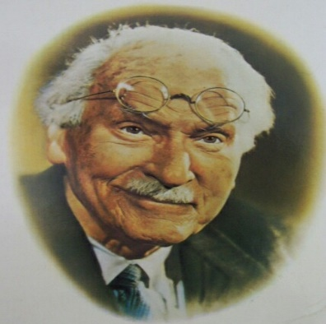

Jung’s Mind: For the last month, APC has not put on the web quotations from C.G. Jung. We have again begun to do so. For instance, Jung stated that:

“The meeting of two personalities is like the contact of two chemical substances: if there is any reaction both are transformed.”

and

“I am not what happened to me, I am what I choose to become.”

We hope that members read and react to these quotations and a dialog may begin between us all.

Dream Interpretation Group
PRESIDENT’S REFLECTIONS

By Joe Moore, PhD, LCSW, Psychotherapist

When I see what is happening in Congress and with the extended and costly presidential race, I had to go back and read Jerome S. Bernstein’s article: “The US-Soviet Mirror” that appeared in the book: Meeting the Shadow: The Hidden Power of the Dark Side of Human Nature. (Eds. Zweig and Abrams. 1991). Bernstein writes: “In conjunction with the archetype of the scapegoat and the archetype of power, the shadow probably has been the most active, disruptive, and dangerous psychic energy operative between the United States and Soviet Union.” (p 214)

In 2015, both stereotypes: scapegoating and power reign throughout the halls of Congress and in the race for the Presidency. The Democrats state the Republicans are only for the wealthy and against everyone else. The Republicans rebuke the Democrats as being against state’s rights and enablers of the poor remaining dependent on “big government.“ Bernstein points out that neither side accepts that they want to dominate the other. The Republicans and Democrats believe they are only doing what they are doing because the other side wants to be in total control of them.

In understanding US – Soviet relationships in 1991, Bernstein writes: “It is important to recognize that, psychodynamically, shadow projection has more to do with domestic self-image than it does with the nature of the perceived enemy although there may be many truths in the context of the projections.” (p 215) Of course all politicians are absolutely self-protective of their images in front of their constituencies. But now the various political groups, the Tea Party, the Conservative Republicans, the Liberal Democrats and the Middle of the Road Democrats are so protective of their public images that they cannot compromise about anything. For instance, the Democrats feel that if they open any discussion of the “Affordable Care Act” their constituencies will attack them, and the Republicans know that if they do not continue with their stances on abortion, and taxes, they will lose much of their base.

Unfortunately, Bernstein’s thesis does not include answers but is more a description of the reasons behind the conflict. Jung said: “Knowing your own darkness is the best method for dealing with the darknesses of other people.” This means pulling back one’s projections and understanding that these projections are really one’s own. As Pogo says: "We have met the enemy and he is us.” The very sad and very dangerous thing is that there are very few, if any, politicians that are willing to put aside their Big Egos to be able to look at their shadows.

THE ANALYTICAL PSYCHOLOGY CLUB’S EVENING PROGRAMS

PRESENTS

CREATIVITY AND THE QUEST FOR PERFECTION:

WHAT IT MEANS WHEN NOTHING SEEMS GOOD ENOUGH

A WORKSHOP BY HELEN ALTIERI, NCPsyA

TUESDAY: NOVEMBER 10, 2015
6:00 PM TO 8:00 PM
Trusting your instincts and feelings, playing with your ideas, and expressing your point of view are the foundations of creative expression and work in any field. But all too often, what initially seems exciting and engaging is crushed by the weight of overwhelming anxiety, unrealistic expectations, and self-doubt.

This workshop will explore why these feelings and fears are so common and so powerful - and why we may feel that nothing is good enough even before we even begin to try. The goal of the workshop is to gain some insight into this self-defeating cycle and to develop some tools and techniques that will embolden the vibrant creative self.

The workshop will draw extensively from case material, and is designed for clinicians and non-clinicians alike.

Helen Altieri NCPsyA, has been a practicing Psychoanalyst in New York City for
more than twenty-five years, working extensively with people in the performing
arts. She has led numerous workshops and seminars and has been on the
faculty of the National Psychological Association for Psychoanalysis, NYU, and the 92nd Street Y.

Program Fees: APC Members/Seniors $10;
Non-Members $20; Students with valid ID $15

Phone Inquiries: 212-557-1502
or
Email: contact @jungclubnyc.org

Eleanor Bertine Auditorium, C.G. Jung Center, 28 E. 39th Street NYC
The C. G. Jung Center of New York is pleased to announce
A Red Book Event
March 4-5, 2016
From February 29 to April 1, 2016, an exhibition of the Digital Fusion prints from Jung’s
Red Book (theredbookprints.com) will take place at the Salena Gallery of Long Island University - Brooklyn (www.facebook.com/liubrooklynart).
You are cordially invited to the Opening Reception on Friday evening, 6:00-8:00pm, March 4, at the gallery at One University Place, Brooklyn. These magnificent 25x33 inch reproductions of Jung’s paintings made their art world debut at the 55th Annual Venice Biennale in 2013, where the original manuscript of the Red Book was on display.
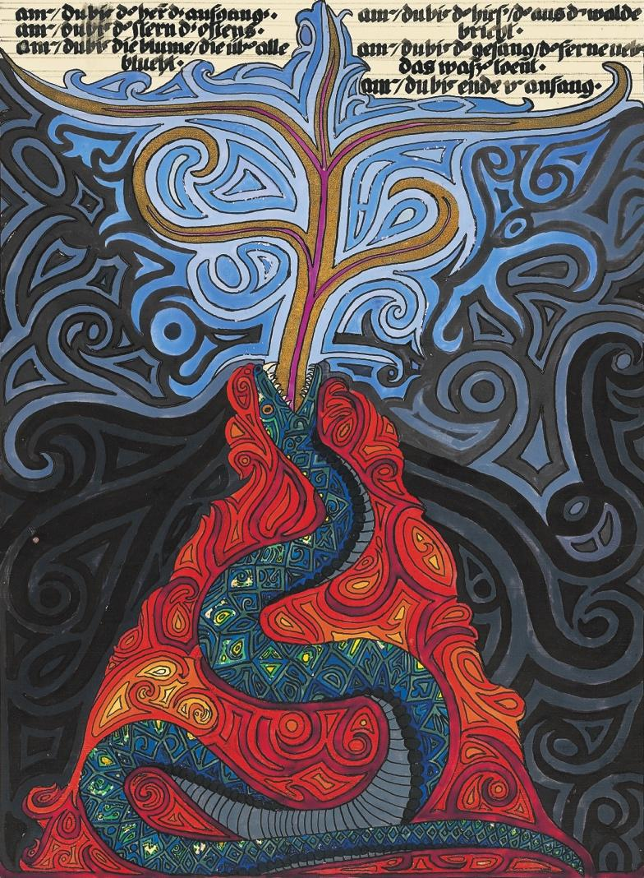
In conjunction with the exhibit, a Conference will be held on Saturday, March 5, at the
C. G. Jung Center of New York, 28 East 39th Street. Entitled Snakes, Dragons, and Other Scaly Creatures, the Conference is co-sponsored by the C. G. Jung Institute of New York (http://www.junginstitute.org), the New York Association for Analytical Psychology (http://www.nyaap.org), the C. G. Jung Foundation of New York (http://www.cgjungny.org), the Archive for Research in Archetypal Symbolism (http://aras.org), and the Analytical Psychology Club of New York (http://jungclubnyc.org).
Snakes, Dragons, and Other Scaly Creatures
Saturday, March 5, 2016
The C. G. Jung Center of New York
28 East 39th Street
New York, NY
CONFERENCE REGISTRATION

From February 29 to April 1, 2016, the Salena Gallery of Long Island University - Brooklyn will host an exhibition of the Digital Fusion prints from Jung’s Red Book. All conference participants are cordially invited to the Opening Reception on Friday evening, March 4, at 6:00 p.m. at the gallery at One University Place, Brooklyn.
On Saturday, March 5, the Conference will take place at the Jung Center, 28 East 39th Street in New York City. Snakes, Dragons, and Other Scaly Creatures will open with a keynote address by Ami Ronnberg, Curator of the Archive for Research in Archetypal Symbolism (ARAS), followed by 30-minute presentations by Jungian Analysts and Training Candidates, focusing on images of the serpent and its multivalent representations. The presentations will lead us into realms such as psychological theory, mythology, clinical practice, and contemporary culture. The format will be three moderated panels, each featuring three speakers, with time for lively discussion. Registrants will receive details of the full schedule in December.
Registration and payment via Eventbrite: www.snakesanddragonsnyc.eventbrite.com

Fee for the conference is $100. $150 after January 1.
Early registration is recommended, as space is limited.
For questions, please email snakesanddragonsnyc@gmail.com

The C. G. Jung Center: 28 East 39th Street, New York, NY 10016

